**WELCOME**

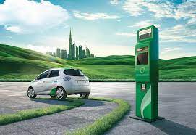 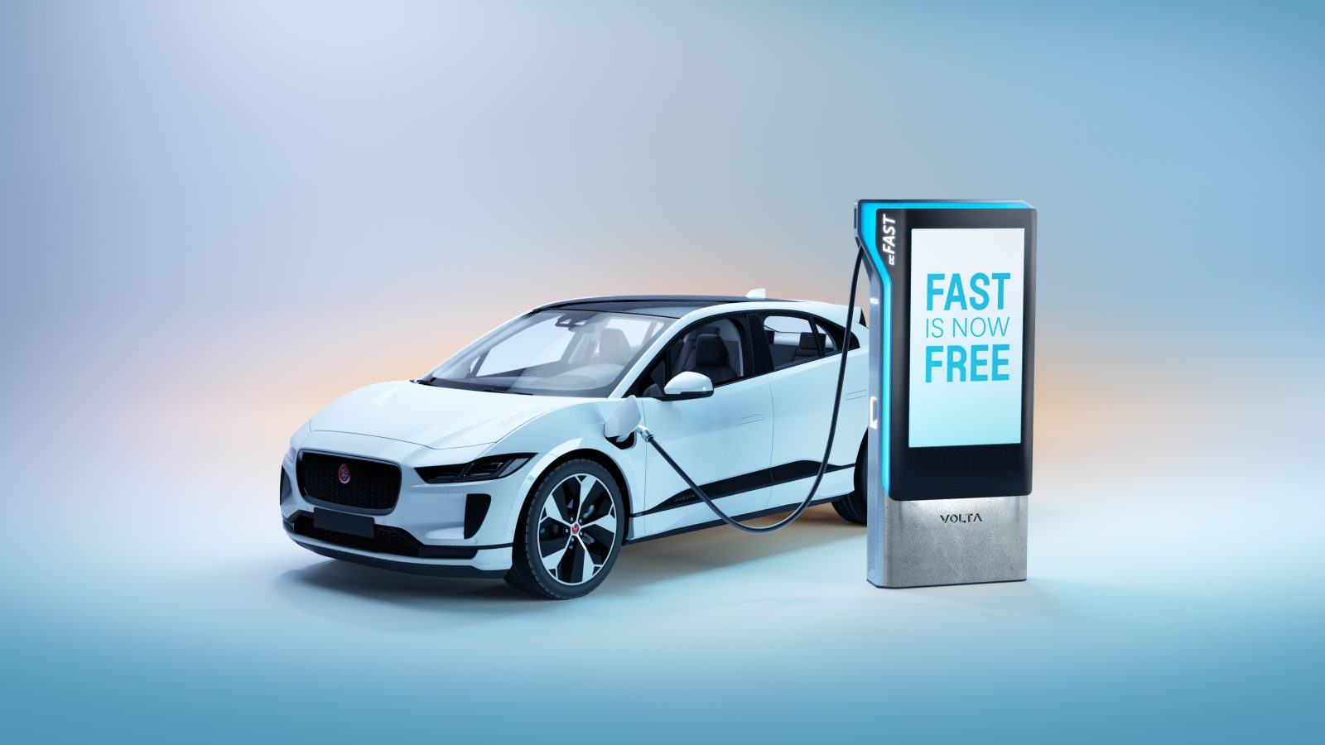

**PROJECT TITLE**

**TEAM LEADER**: ANUSHA MOL .J

**TEAM MEMBERS**: AGINA.J

AISWARYA.V.S

ANISHA.A.S

ANOOP.S.R

**SUBMITTED BY**

**VISUALIZATION TOOL FOR ELECTRIC VEHICLE CHARGE AND RANGE ANALYSIS**

**PROJECT REPORT**

1. **INTRODUCTION**

1.1. OVERVIEW

1.2. PURPOSE

**2. PROBLEM DEFINITION & DESIGN THINKING**

2.1. EMPATHY MAP

2.2. IDAETION & BRAINSTORMING MAP

**3. RESULT**

**4. ADVANTAGES AND DISADVANTAGES**

**5. APPLICATIONS**

**6. CONCLUSION**

**7. FUTURE SCOPE**

**VISUALIZATION TOOL FOR ELECTRIC VEHICLE CHARGE AND RANGE ANALYSIS**

**1. Introduction**

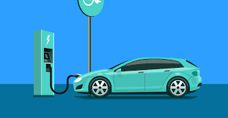

Electric vehicles that are either partially or fully powered on electric power . Electric vehicles have low running costs as they have less moving parts for maintaining and also very environmentally friendly as they use little or no fossil fuels.

2. PROBLEM DEFINITION & DESIGH THINKING

**EMPATHY MAP**

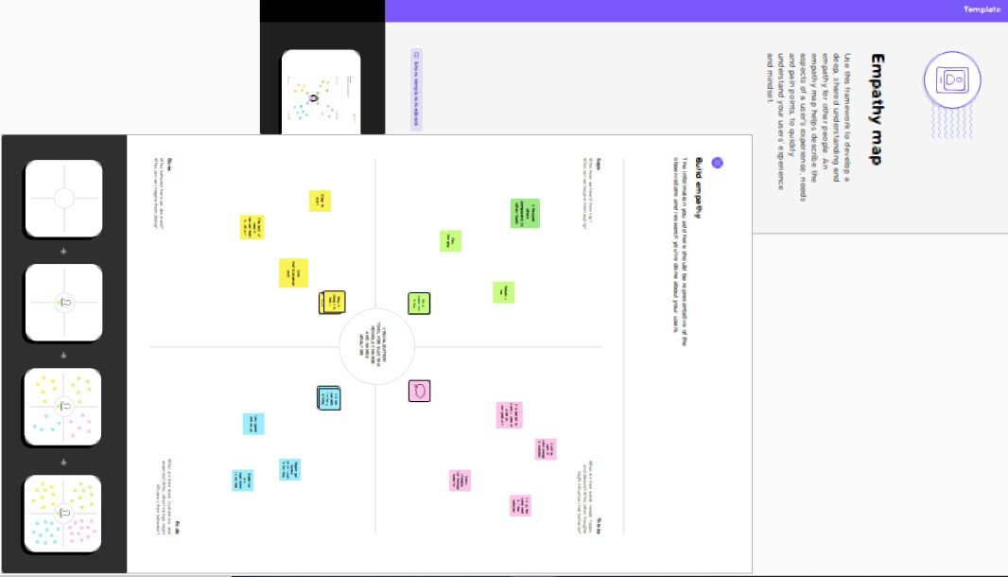

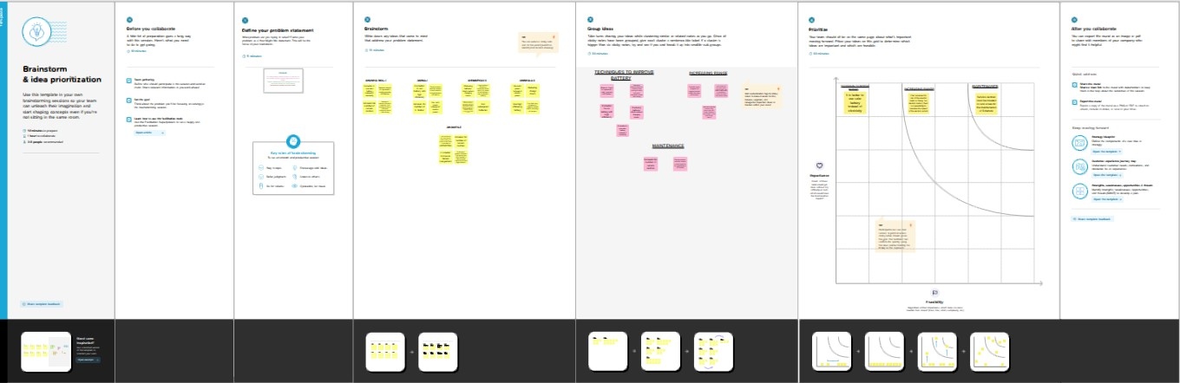

**BRAINSTORMING AND IDEATION MAPMAP** & BRAINSTORMING MAP

**3. RESULT**

**DASHBOARD**

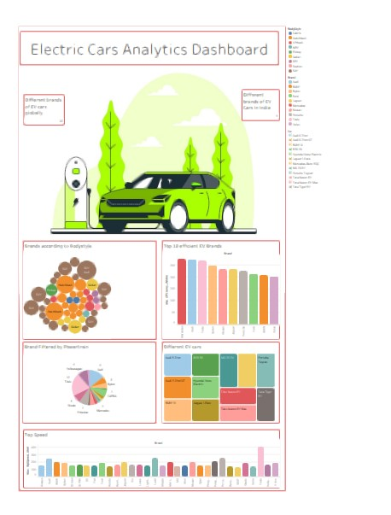

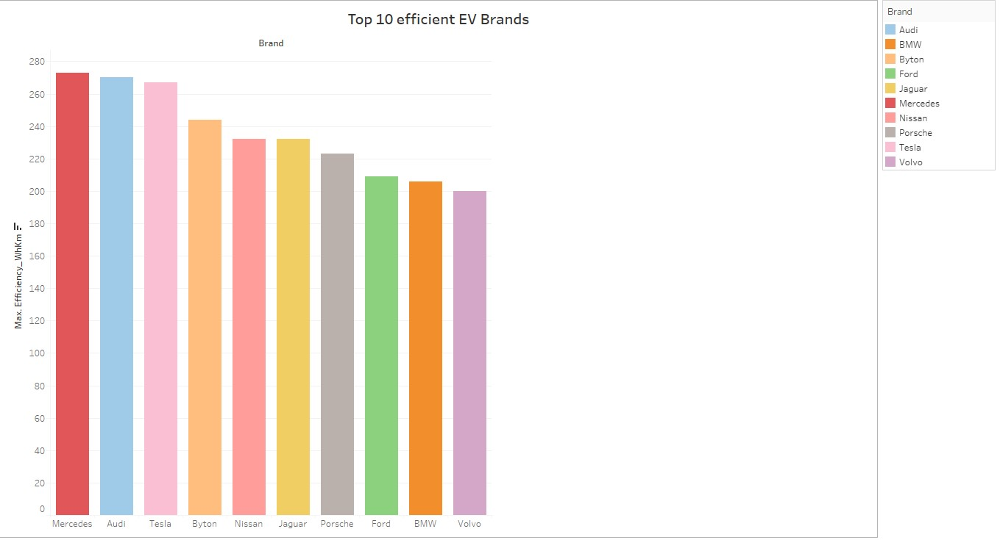

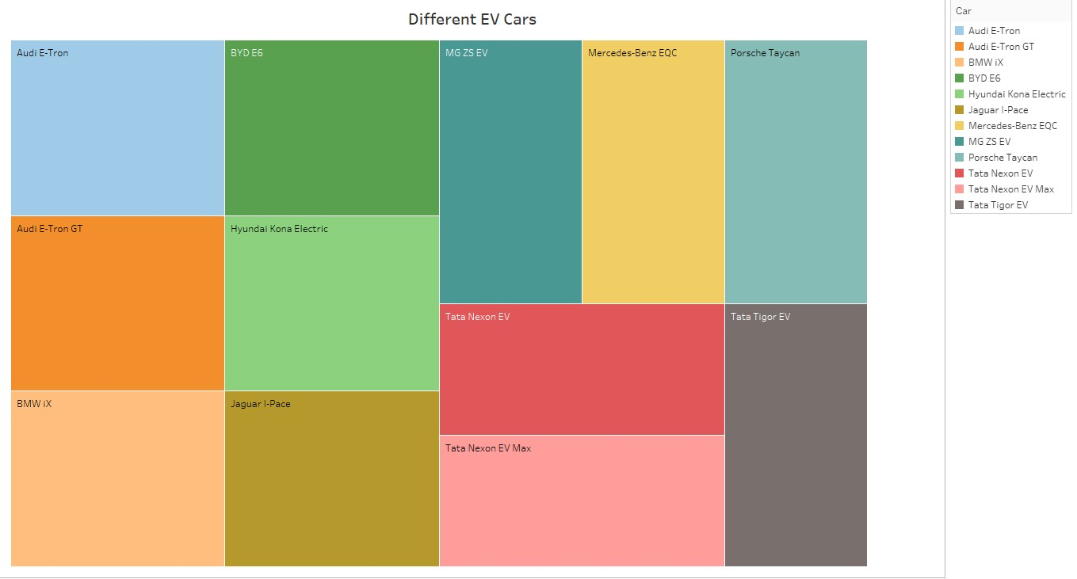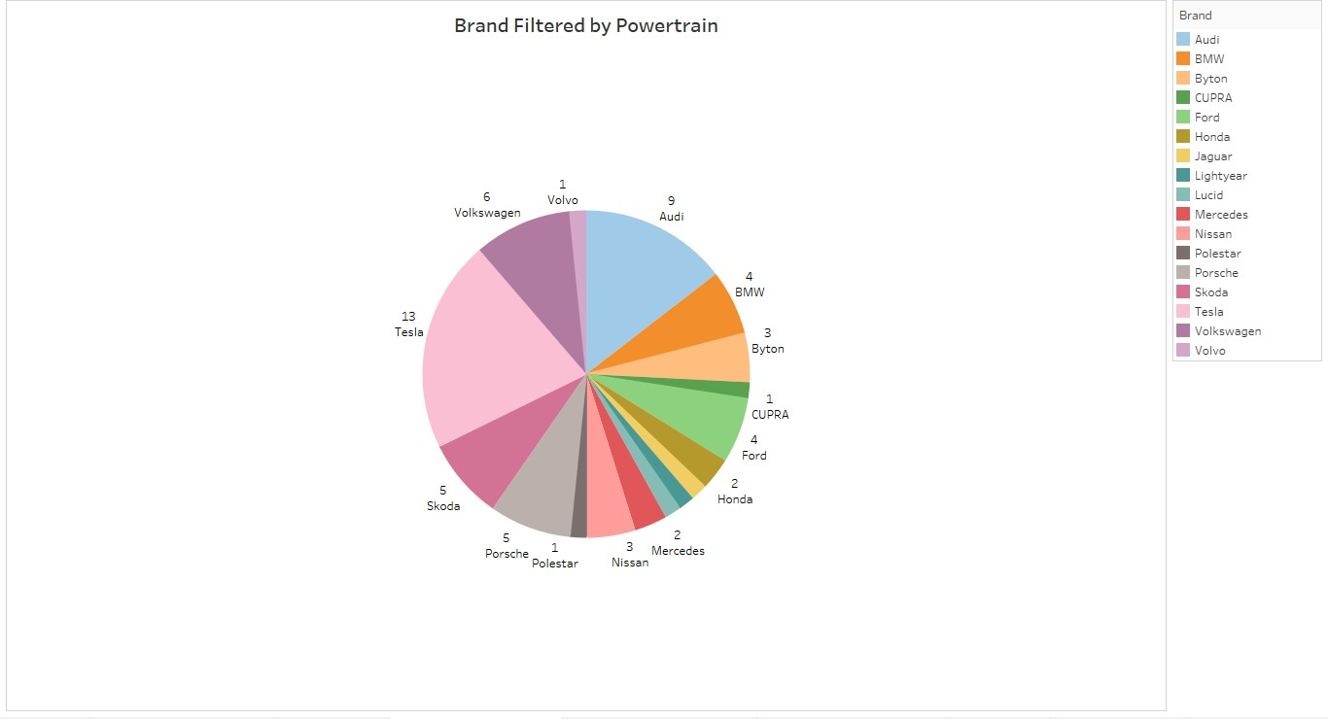

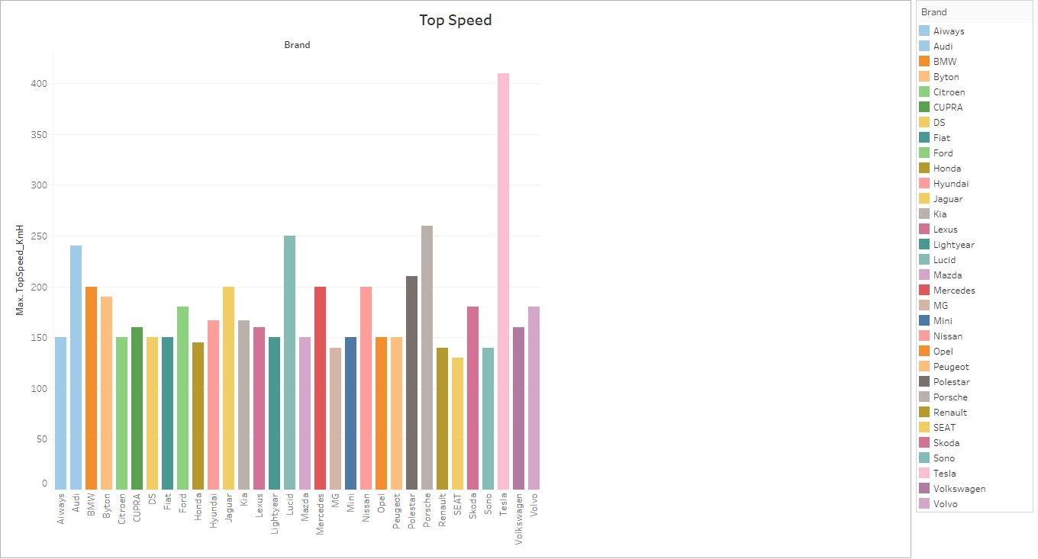

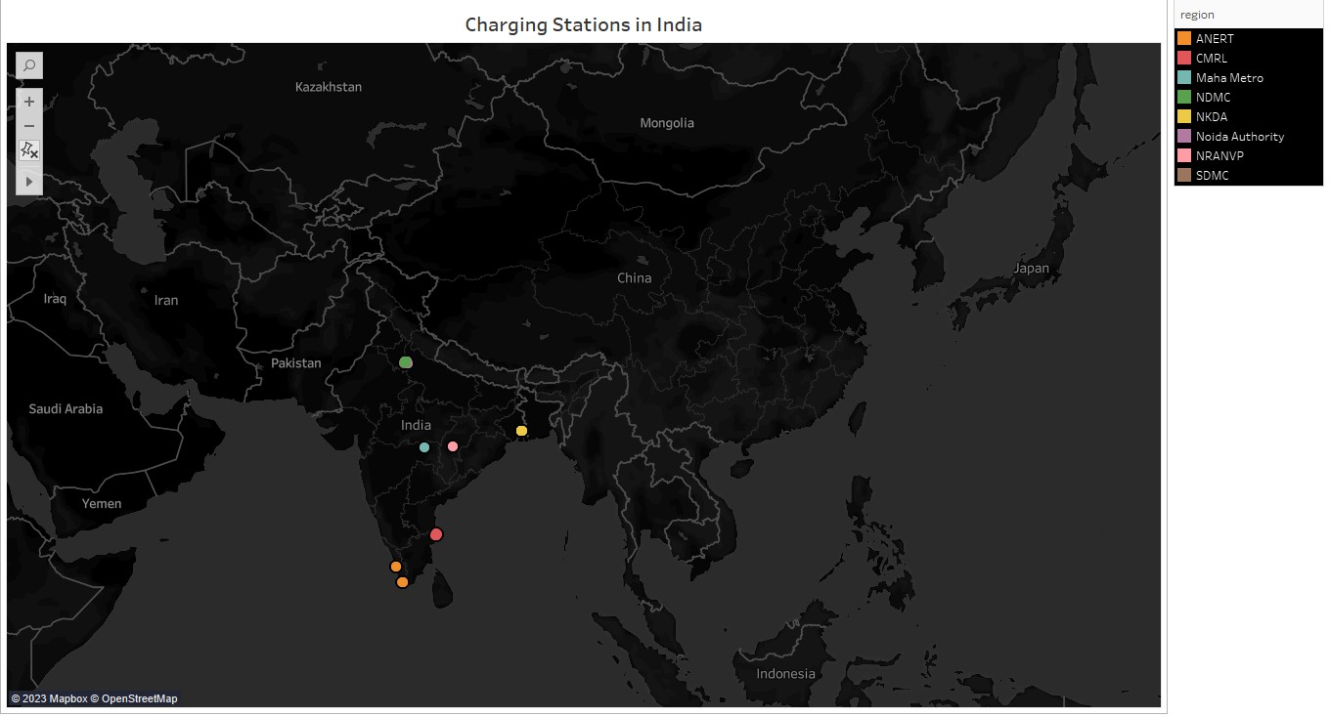

**STORY**

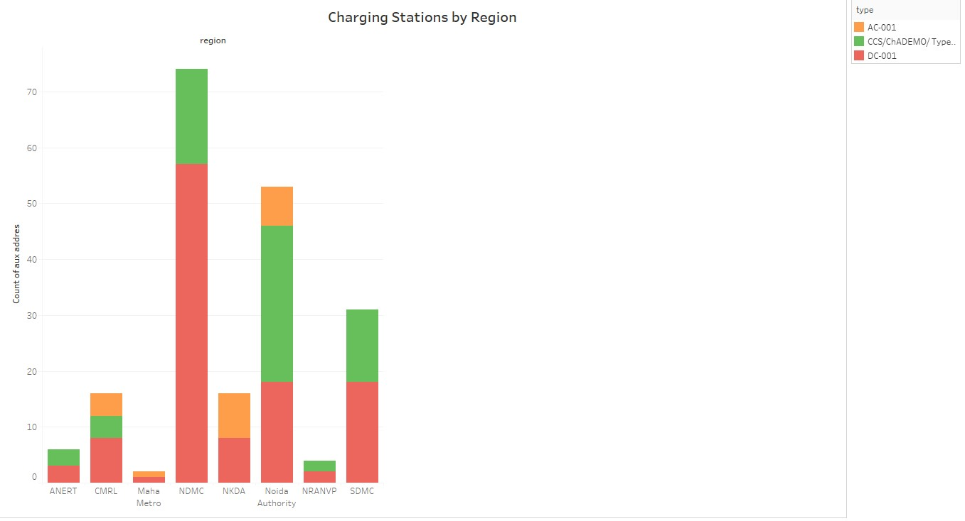

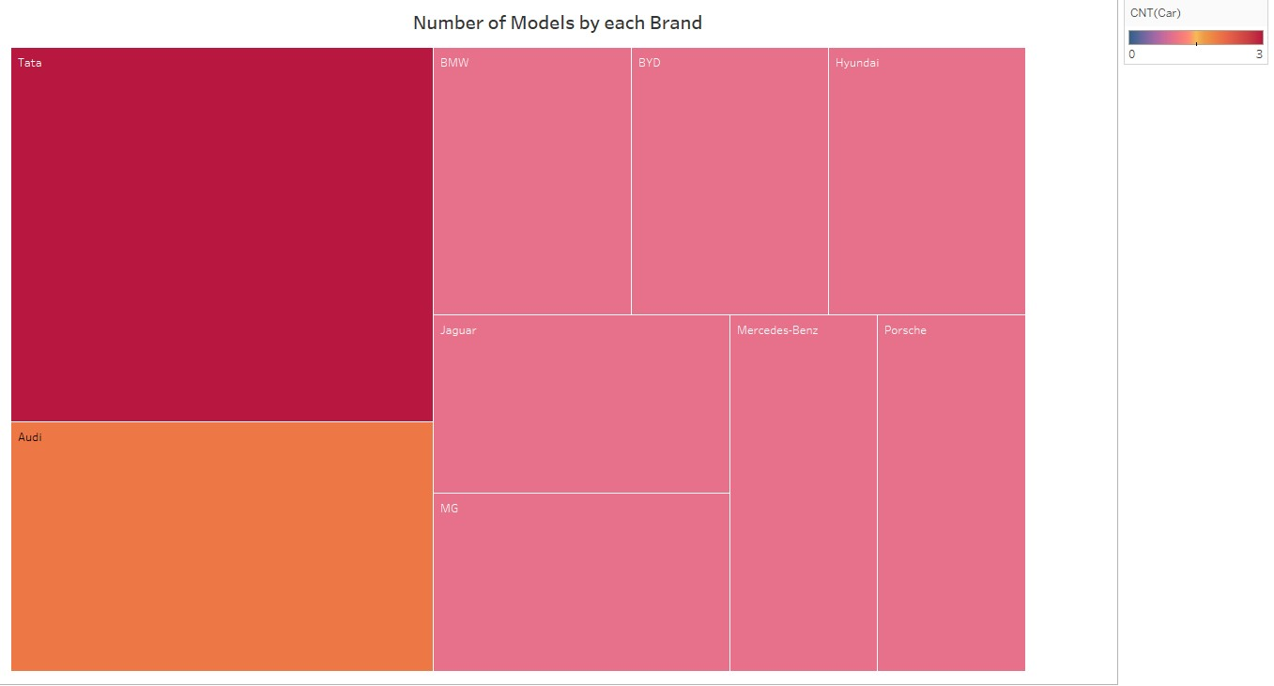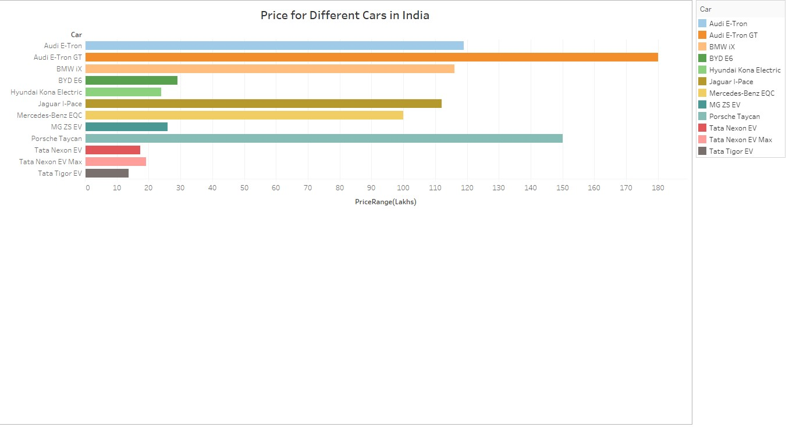

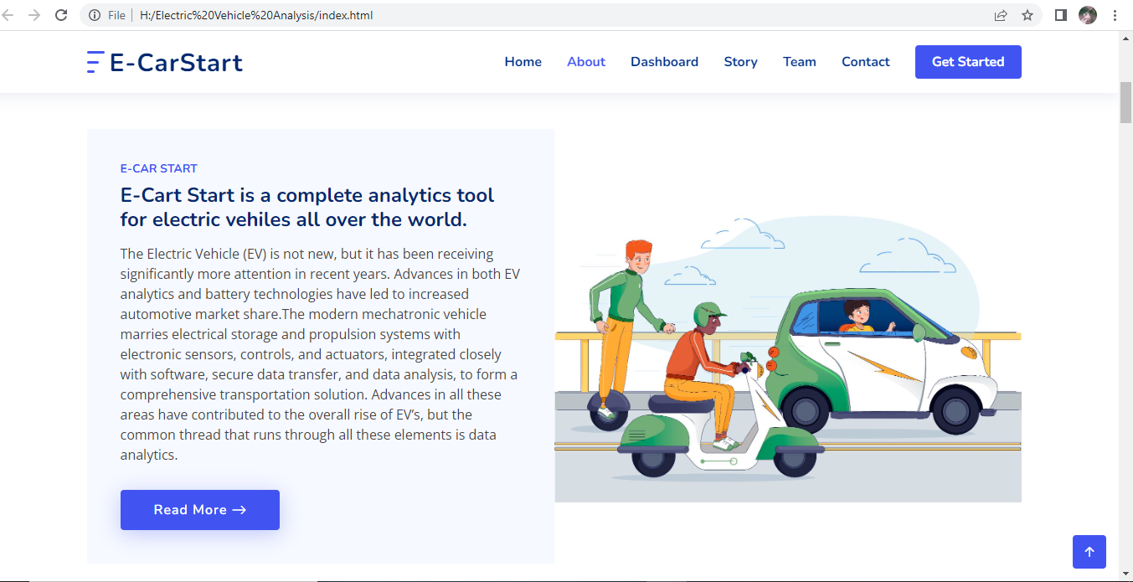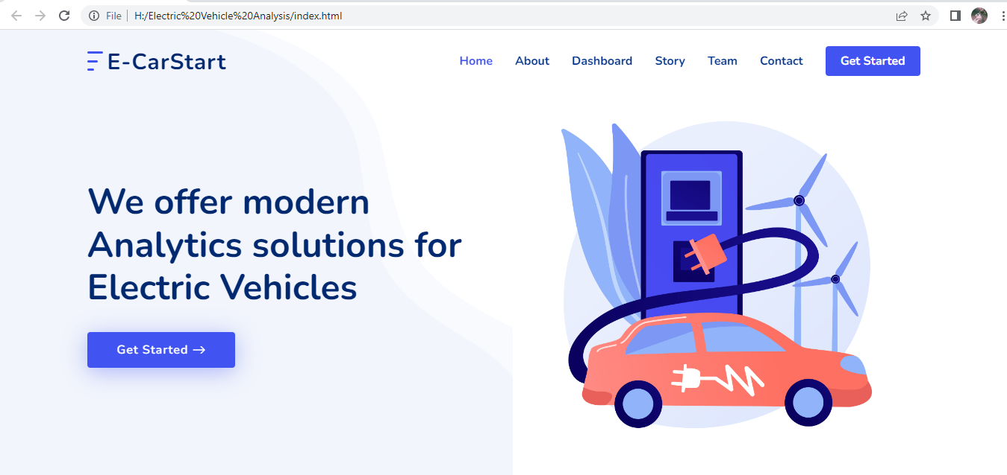

**WEB APPLICATION**

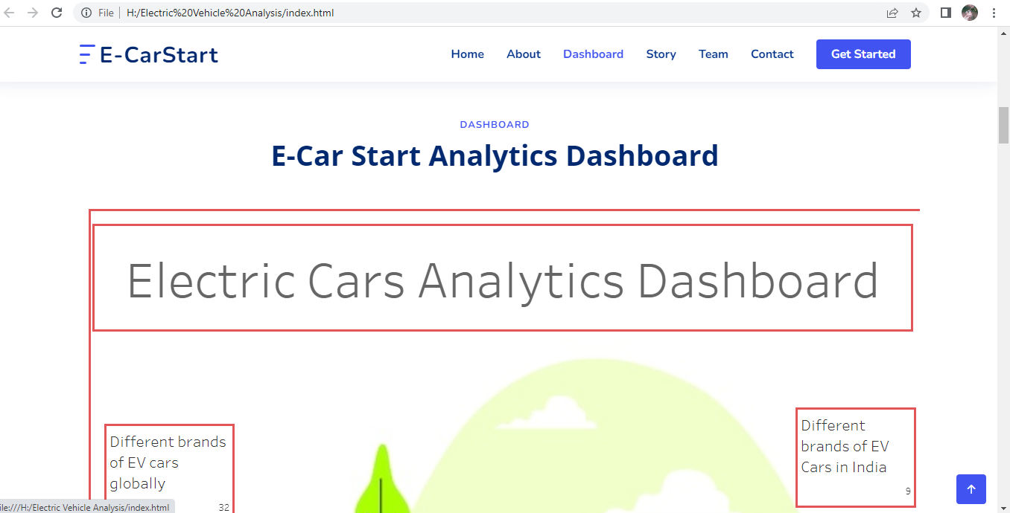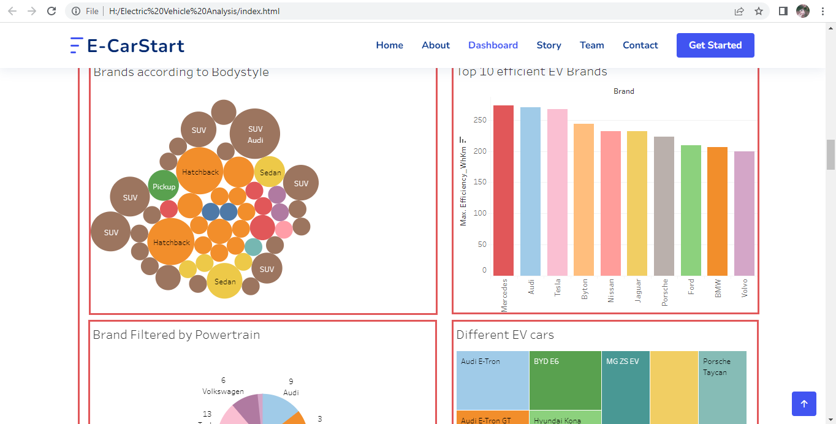

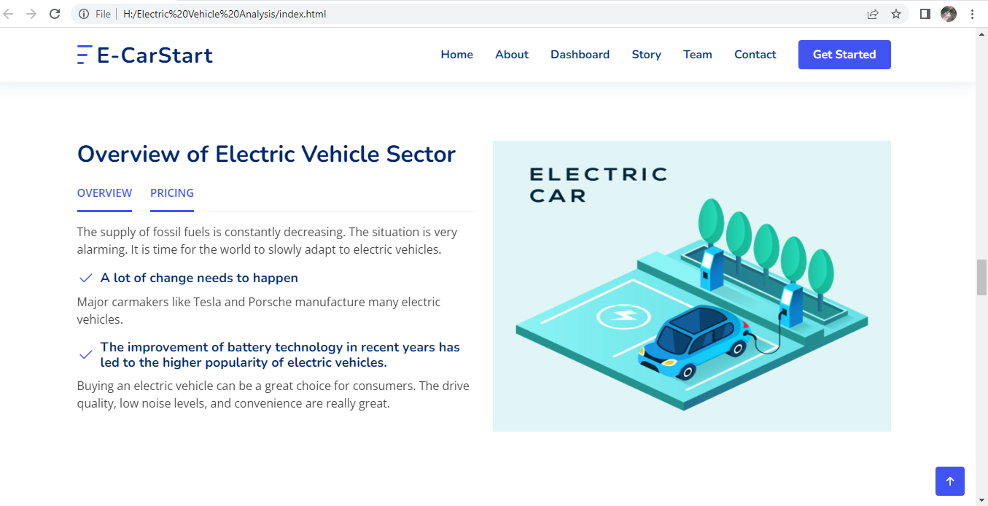

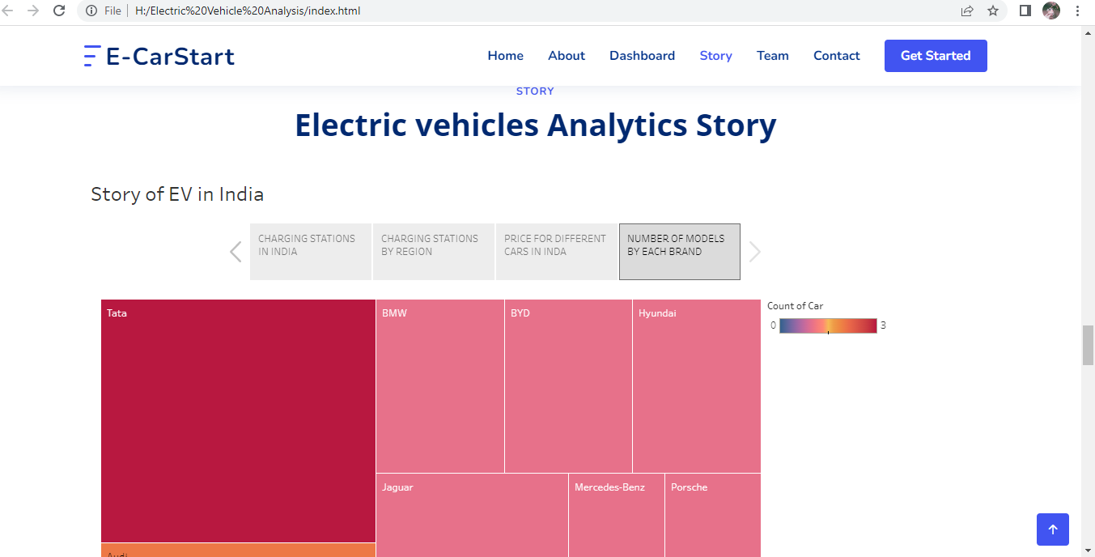

**4. ADVANTAGES & DISADVANTAGES**

**ADVANTAGES**

* **Environmental friendly as they do not emit pollutants.**
* **Lower maintenance due to an efficient electric motor.**
* **Driving an electric car is significantly smoother. They are quitter and produce less noise.**
* **No fuel required so you save money on gas.**

**DISADVANTAGES**

* **Electric cars can’t travel as far.**
* **Electric cars can be expensive.**
* **Electric cars can take a long time to recharge.**
* **Power stations not available in rural place.**

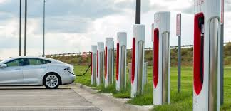

**5. APPLICATIONS**

Electric vehicles use electricity to charge their batteries instead of using fossil like petrol or diesel. Electric vehicles are most efficient and that combined with the electricity cost means that charging an electric vehicle is cheaper than filling petrol or diesel for your travel requirements .

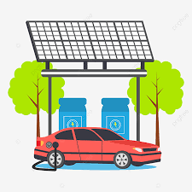

6. CONCLUSION

The basic conclusion is that when it comes to climate change and air quality, electric cars are preferable to petrol or diesel cars. Some public doubts and uncertainties about the environmental benefits of electric cars, the science is increasingly clear.

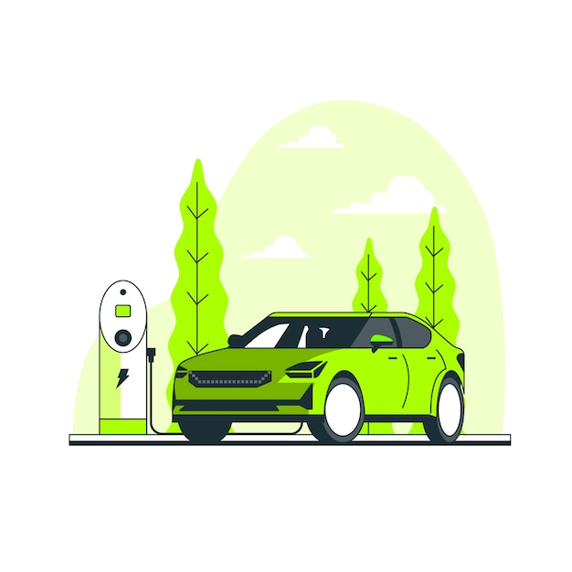

7. FUTURE SCOPE

Consumers in india are looking for a lower price for Electric Vehicles than those other countries, with the global average tipping price for Electric Vehicles being $36,000.

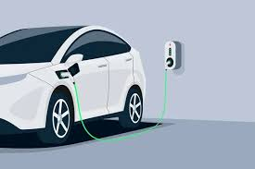

**THANK YOU**